How do parachutes work?
Part 1 :
Materials :
- 3 sheets of letter size paper
Procedures :
A-
1- roll one sheet of paper into a ball

2- hold another sheet of paper flat (eye level)
3- hold the ball of paper at the same height
4- drop both sheets simultaneously
5- note which paper hits the ground first
6- try it from different heights
7- is the result the same or are there any changes

B- 1- take the 3rd sheet of paper and roll it into a cylinder
(you can use a piece of tape to keep its shape)
2- redo experiment A but replace the flat sheet with
the cylinder held vertically
3- are the results the same

Questions: Answers
(remove the box to reveal the answers

1- What slows the paper as it falls? air

2- What causes the differences in A? The balled paper has less air under it

3- Why are the results in B different from A? the cylinder has less air and cuts
Through it
4- Does this prove that air occupies space? Yes. Air is matter and has mass,
volume and inertia

Part 2:

Materials:
- 2 different size garbage bags
- 2 small sandwich bag (for weight)
- Sand or a small toy
- String
- stapler and/or tape

Procedures :
1- cut the garbage bags in half 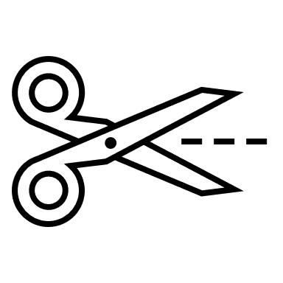
2- keep the bottom half which is closed
3- place some sand (about ¼ cup) in each of
the sandwich bag and close it
4- cut eight pieces of string of equal length (about 45cm)
5- staple two pieces of string to one corner of sandwich bag and two other
pieces to the other corner
6- staple the other ends evenly spaced to the open end of the garbage bags
7- if you can go outside throw the parachute up as high as you can and see how

long it takes to come back to the ground
or
if you do this inside, ask an adult to hold
the parachute open as high as they can
drop it
8- repeat several times till you can see
how the size of the parachute affects
the time it takes to deliver the bag to the ground

Question:

1- How does the size of the parachute affect the speed at which the same loads fall to
the ground?
The bigger the parachute the slower it falls

2- Why is there a difference between the big parachute and the small one?

The force pulling both parachutes down is the same since the sandwich bags have the same mass. The bigger parachute has more air to displace than the smaller one therefore it takes more time to move it out of the way than the smaller one
Part 3 :

Using the material in Part 2, can you build an experiment that could explain how the size of a parachute would be affected by different size loads.

Write down your procedures and your observations.

