Technology Activity week 4!

Thank you to everyone who sent me a presentation last week. I loved seeing what you guys are up to and they made my week.

This week we will be doing an activity on Scratch.
In case you missed the instructions on a previous week on how to get Scratch, I will repost them below.
- There are TWO WAYS to use Scratch. The first is going to Scratch website, https://scratch.mit.edu/ and then go to “CREATE”. You can save your work by either creating an account and your work will be saved there, OR simply do File: save to your computer and file will be found in your downloads folder.
- Another option is to download Scratch desktop. That means the Scratch program will always be on your computer and you will no longer need internet to use it. You can also save to any place on the computer that you prefer. https://scratch.mit.edu/download

- Once you are on Scratch, go to “Tutorials.”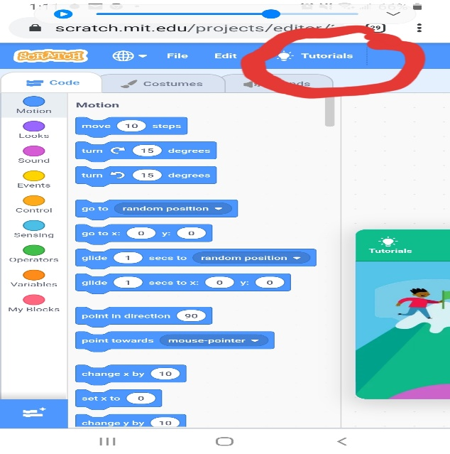
- Go to tutorial “Talking Tales.” 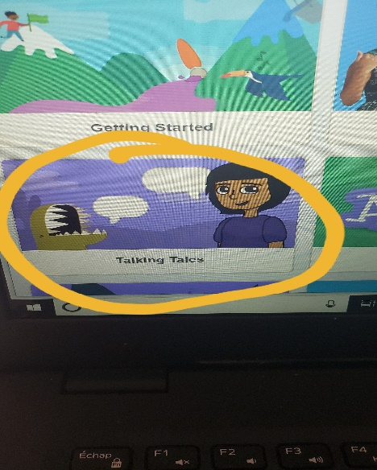
- Follow the arrows on the tutorial to get your sprites to speak out loud! (sound is necessary so headphones might be a good idea for this.)
- You can follow the tutorials as much as you want, OR you can create your own animation using the “Text to speech blocks.”
- IF following the whole tutorial, I recommend trying the “Animate Talking” animation and “Dance Moves.”

Feel free to make your animation your own, and have fun!!

As always you can send your work and questions to kboyer@emsb.qc.ca

