Dear Parents and Students, welcome to week 4 of the student learning kits. This week there are some great activities about the components of physical fitness and exploring movements with a ball. In addition, there is a family game of snakes and ladders.
Learn About the Components of Physical Fitness and Get Moving!
Information for students
Activity 1:
- Look at the following document and/or video to learn about the components of physical fitness:
  - Document: Components of physical fitness
  - Video: The 5 Components of Health-Related Fitness
- What did you learn about physical fitness by watching the video? What can you do to improve your own fitness? Can you name or show some movements that explain the various components of physical fitness?
- Discuss what you learned about physical fitness with a member of your family.
Activity 2:
- Try out the workout suggested in the following document:
  - Activity 2: Exploring movements with a ball

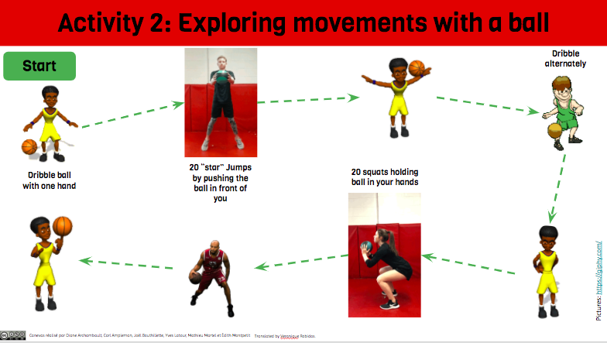
- Invite a member of your family to do the workout with you.
- Associate each movement you did with a component of physical fitness

Materials required
- Device with Internet access (for Activity 1)
- Ball (for Activity 2)
Information for parents
About the activity
Children should:
- learn about the essential components of physical fitness and how to improve their own fitness
- carry out physical activities related to the components they learned about

Parents could:
- ask questions about what their child has learned about the components of physical fitness
- discuss the importance physical fitness with their child
- participate in the workout together with their child

Activity 3: Time to Dance
https://www.montrealalouettes.com/2020/04/21/entrainement-special-seniors-claudia/?fbclid=IwAR0Ev44CDGvlUpK1ccWVHyJ4pBRsf-WFSEKyxTNiKyhzlqHW_wt_xS7gdWk

Activity 4: Snakes and Ladders game and instructions see below

60  FINISH | 59  Jog on the spot for 30 seocnds | 58  Dance 10 seconds | 57  5 Push ups | 56  10 sit ups | 55  Stretch to the left
49  15 seconds high knees | 50  5 burpees | 51  Name two good hygiene habits | 52  Balance  on one  foot for 10 seconds | 53  Run to the kitchen/bathroom and back | 54
48  Name 2 active activities | 47  Plank 15 seconds | 46  Stay hydrated drink a glass of water | 45 | 44  Crab walk around the couch | 43  Stretch to the right side
37  10 push ups | 38  Wasn your hands with soap for 20 seconds | 39  15 toe touches | 40 | 41  Toss and catch  a pair of socks x 5 | 42  10 jumping jacks
36  Stretch to the right | 35  Name 3 healthy breakfasts | 34 | 33  Name 4  good sleep habits | 32  Hop on one foot  x10 each | 31  6 burpees
25  Name 5 healthy snacks | 26 | 27  5 jumps | 28  High five two  people | 29 | 30  Stay hydrated-drink a glass of water
24  Jump side to side x 5 each | 23 | 22  Name 3 sedentary activities | 21  Skip around the house | 20  10 toe touches | 19  Wall sit 20 seconds
13  High 5 two people | 14  Balance on one leg for 15 seconds | 15  10 skips | 16  30 second plank | 17 | 18  8 squats
12 | 11  10 bum kicks | 10  Wall sit for 20 seconds | 9  Sit and reach-hold 10 seconds | 8  8 burpees jump-push up | 7  Dance for 10 seconds
1  START | 2  Run touch wall  x 2 | 3  15 sit ups | 4  20 high knees | 5  15 sec plank | 6  5 jumps

Instructions for Snakes and Ladders:

Material required:
- Dice

Paper version
- Scissors (if playing on paper version) or use other tokens such as rocks to mark your spot on the board
- Printer

Tokens:
- Cut out if playing on paper. If you are playing on the Word document these tokens can be moved onto the playing board.

How to Play:
- Each player puts their token on the space that says ‘start here’.
- Take turns rolling the dice to see who starts the game, the person to their right goes next.
- Roll the dice again to move your token forward the number of spaces shown on the dice. If your token lands at the bottom of the ladder, you can move up. Before going up the ladder, you must complete the exercise first. If the square is empty you can move your token right up.
- If your token lands on the head of the snake, you must slide down to the bottom of the snake.
- The first player to land on the ‘finish’ space wins the game.
- To play you need a minimum of two players.
- Remember to complete the exercise after rolling the dice and moving your token.

Keep active and keep learning. Email and let us know if you are liking the activities and let us know activities you would like to do.

Stay Safe and Healthy,

Mr. M dmccarthy@emsb.qc.ca
Ms. Quinn tquinn@emsb.qc.ca

